Appendix A: IPPR Gender and Devolution Report

Summary: June 2017

About the research and purpose

- The devolution of power to local and regional levels has the potential to radically reshape England’s democracy and improve the way decisions are made for local areas. But current governance models present challenges for representative democracy; specifically, the huge under representation of women on combined authority boards and in the leadership of councils with agreed devolution deals.

- This research shows that in the six mayoral elections that took place in combined authorities in May 2017, no women were elected. Of the six combined authorities who elected mayors, 95% of CA members (e.g. the leaders of constituent councils) are men.

- There are two ways to approach improving gender representation in combined authorities; looking at the structure of combined authorities, and looking at pipelines into them. A focus on combined authorities necessitates looking at local government, as CA boards are predominantly made up of representatives from constituent local authorities.

- This research complements the work of others, including the Fawcett Society’s Local Government Commission, by looking at national and international approaches to improving representation in local and regional government and by examining the role of political parties as well as local government in this.

- We assess the performance of England with international comparators and devolved nations, and profile policies and initiatives we have studied to inform our recommendations. Our research methods are: literature review, desk based research, and interviews with political stakeholders from all parties as well as international interviewees.

Key findings at the time of writing

- Combined authority boards are almost entirely composed of men.
  - In the West Midlands for example, there are no women councillors in the mayor’s cabinet (covering both the 7 constituent council members, with voting rights, and its 5 non-constituent council members, without voting rights), while the same is true for the West of England and Liverpool City Region. In total, across the new cabinets, there is a 94 per cent male representation rate.

- Women councillors are less likely to have responsibility for key devolution deal policy areas, such as business, finance and regeneration.
  - We have looked at the cabinet positions held by the 128 women who are currently cabinet members in councils that have agreed devolution deals as part of combined authorities or otherwise. We have analysed the frequency with which particular words feature in women’s portfolios. Notably, business, procurement, jobs, regeneration and finance are unlikely to feature in the portfolio of a women council cabinet members. In contrast, the words health, children, community, social care and wellbeing feature much more heavily. (This is a particular issue given current devolution deals are focused on the former.)

- Progress on gender representation in local government has stalled in the last twenty years and varies widely by local authority and party.
  - While local councils in England have historically delivered greater representation for women than national politics, this has recently plateaued –at around a third (32 per cent), having already been as high as 27.8 per cent in 1997.

- Women are less likely to be local government leaders.
  - Ahead of local elections in May 2017, only 17 per cent of council leaders were women, amounting to just 56 women leaders, an increase of only two points on 2014/15.

- Women are less likely to stay in post over time, and less likely to progress into other levels of government.
  - Women are more likely to serve a maximum of just two terms (65 per cent versus 57 per cent of men) and where councillors are in office for long periods of time, of at least twenty years, for every woman in this position there will be three equivalent men.

At what stages are there barriers to women reaching combined authority boards?

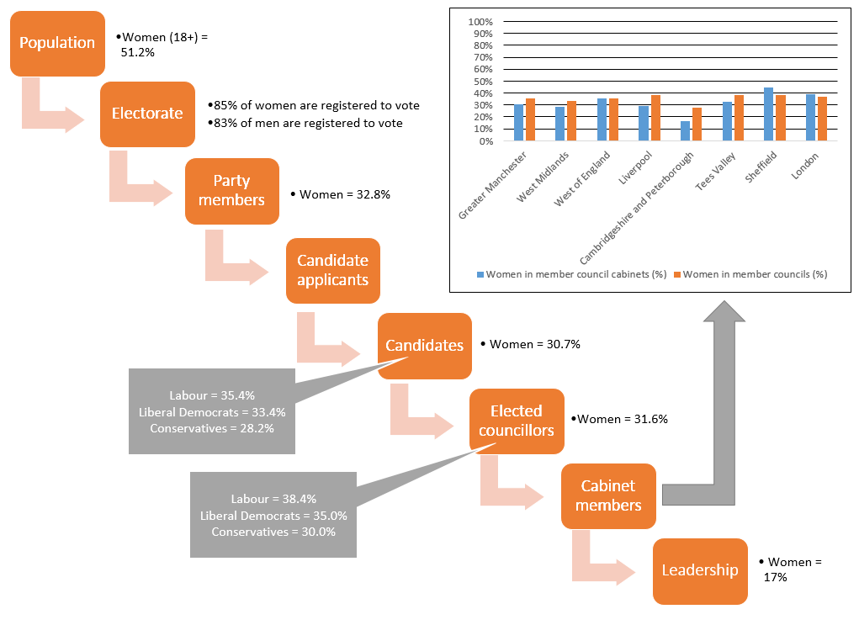

- We identify two main points at which women become much less likely to progress through the journey to combined authority positions than men:

  - Party membership (which could also reflect fewer women wanting to join in order to become local politicians).

  - Reaching leadership positions.

- Barriers are multiple:

  - Women are less likely to be party members. Evidence suggests this is because of sociological factors such as work status, education and cultural norms around participation of women in public life (which varies with religion and geography), because of time constraints, parties not appealing to women and the issues that are important to them, lower internal political efficacy among women and potentially women finding entry into elected politics less appealing than men.
  - The job of a councillor may be less appealing to women, in particular because of workload and timings of meetings, council cultures including sexism, and a lack of self-belief (Fawcett Society’s Local Government Commission, IPPR interviews, Rao 2005).
  - Party processes are key in determining who is selected to be a candidate, where they are selected, and which councillors progress to leadership positions. Outdated models of ‘leadership’, informal selection procedures and informal network building, and lack of advocacy for women politicians are all potential barriers that women face.
Initiatives and policies to address the lack of representation of women in local politics and combined authorities

- We researched initiatives in England as well as other countries, finding them to vary on two axes:

  - The extent to which the initiative focusses on the woman as opposed to organisations and systems.

  - The point in the lifecycle of entering and progressing through politics.

 | Empowerment model | Institutional and party interventions | Systemic interventions
Candidate emergence | e.g. confidence building | e.g. changing party culture
Candidate selection and election | e.g. political skills training | e.g. voluntary party all-women shortlists | e.g. mandatory quotas, electoral systems
Candidate retention |  | e.g. changing working hours
Candidate progression into leadership roles | e.g. mentoring for existing councillors |  | e.g. requiring deputy leaders to be members of combined authorities

- In England, our research will profile the following interventions, and mention others:

- Empowerment programmes

  - Girl Guiding’s civic action and political campaigning activities

  - The Parliament Project

  - Political party mentoring programmes

  - DivaManc

  - Identification of positive role models and programmes within schools and colleges.

- Institutional and party interventions

  - All women shortlists and party quotas

  - Fabiana

- Systemic interventions

  - London Assembly, which has achieved very good gender balance.

  - Changes to the membership and representation in Combined Authorities, such as appointed deputy portfolio holders and councillors deputising for leaders with voting powers.

Lessons from international research

- Scotland

  - Young women value role models and mentors.

  - The Scottish Parliament is more gender balanced in part because of quota policies designed for the electoral system – e.g. ‘twinning’ in single member constituencies, which involves one selection panel selecting one man and one women for two nearby seats; and ‘zipping’ in multi-member districts and additional members systems, in which alternate candidates must be women.

  - Involving women in campaigns and addressing their concerns directly encourages political involvement (e.g. independence referendum).

- Wales – will be featured, analysis is ongoing

- Germany

  - Quotas are highly effective in triggering a step change in representation.

  - A multifaceted approach is needed if women are to achieve meaningful equality – including programmes to help them progress through politics once elected and interventions that seek to break down prejudiced structures and cultures.

  - Parties are the gatekeepers of power: initially and later in political careers.

  - Better data collection and ranking can incentivise local action.

- Sweden

  - There is a reciprocal relationship between position of women in society and women’s representation. Swedish evidence shows for example that an increased number of elected women increases spending on childcare at the sub-national level. Conversely, strong representation of women is associated with women having a high degree of independence and employment.

  - Gender equality institutions such as the Ministry for Gender Equality maintain focus on gender representation and can improve reporting of discrimination

- Other initiatives from around the world:

  - We will profile a number of other initiatives, including a programme to encourage girls to become involved in politics in Northern Ireland, the Canadian Liberal Party’s campaigns to nominate potential councillors and national politicians, and evidence from the business world on how to change structures so that bias cannot affect representation outcomes.

The case for reform

- Evidence from initiatives and policies in other countries suggests some key lessons:

  - It is much easier to create gender equal systems from scratch, than it is to try to change them once established.

  - Parties are gatekeepers of power and instrumental in changing access to politics as well as progression within it.

  - Institutions with responsibility for gender equality can sustain and monitor progress.

  - A single approach, for example only using empowerment programmes, is unlikely to achieve change quickly or comprehensively. Instead a multi-faceted approach is required. Rapid change will require concerted action.

Recommendations

- Only focusing on the pipeline of local government candidates will take a long time to feed through into gender equal representation on combined authorities, because combined authority boards consist primarily of the leaders of constituent local authorities, and usually deputy mayors as substitutes. Progression at senior levels within local authorities, and looking at the structure of combined authorities, will be necessary to achieve change in the early years of new devolved institutions.

- Our recommendations will therefore lay out a vision for how combined authorities can achieve better gender representation through two routes:

  - Ensuring women are represented in local government, including at senior levels, which determines the make-up of combined authorities.
    - Our emerging recommendations will focus on:
      - A potential programme for young girls and women to encourage participation in political parties and local politics.
      - Political mentoring and training programmes that would help women progress into leadership positions, particularly in male-dominated policy domains, in local politics.
      - Voluntary and non-voluntary quota options to achieve a step-change in numerical representation.
  - Look at combined authorities themselves and see how they could be changed and set up to support equal representation, including:
    - The structure of membership e.g. number of representatives from each LA and role of Deputy Mayors.
    - Who is selected to represent constituent local authorities e.g. could this be cabinet members other than the leader or deputy leader?
    - Further devolution to combined authorities, including responsibility for social infrastructure such as health, childcare and social care, which disproportionately affect women, as well as economic infrastructure.
- Our recommendations will be addressed to women’s campaign groups, to political parties, and to local authorities (particularly those which are constituent members of combined authorities). We will reference but not prioritise what can be done to improve councils as a workplace for women (e.g. time of meetings, childcare), as adequate recommendations have already been made by others including the Fawcett Society. Our recommendations will be presented in three categories, mirroring the types of intervention we found in our international research:

  - Empowerment models

  - Party and institutional change

  - Systemic reform

Our analysis includes constituent cabinets of the six combined authorities which elected mayors in May 2017, the 16 women cabinet members across Sheffield City Region’s constituent council cabinets and the newly appointed cabinet for Cornwall Council.
Electoral Commission (2004) Gender and Political Participation
Rao N (2005) ‘The representation of women in local politics’ Policy & Politics, 33(2), pp323-339.

